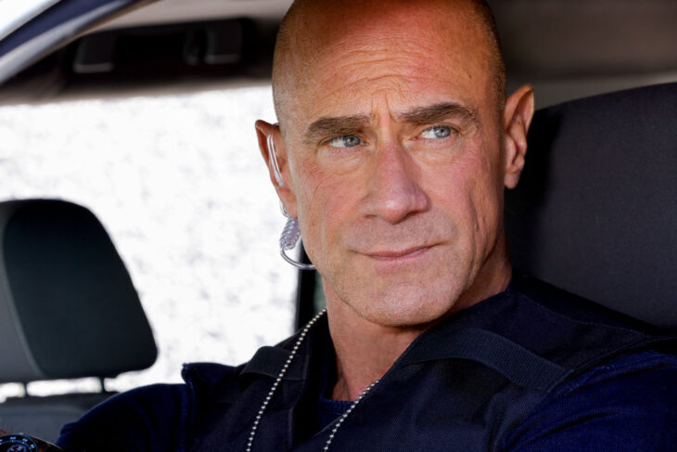

# [Law & Order: Organized Crime Season 3 Episode 6 Review: Blaze of Glory](https://telltaletv.com/2022/11/law-order-organized-crime-season-3-episode-6-review-blaze-of-glory/)

[November 4, 2022](https://telltaletv.com/2022/11/law-order-organized-crime-season-3-episode-6-review-blaze-of-glory/)[Mads Misasi](https://telltaletv.com/author/mads-misasi/)[Law and Order: Organized Crime](https://telltaletv.com/category/law-and-order-organized-crime/), [Reviews](https://telltaletv.com/category/reviews/)

The story from the previous episode continues on [***Law & Order: Organized Crime*** Season 3 Episode 6, “Blaze of Glory.”](https://telltaletv.com/2022/11/preview-law-order-organized-crime-season-3-episode-6-blaze-of-glory/) What could’ve been a great opportunity to continue working with the [***Law & Order: SVU***](http://www.telltaletv.com/category/law-and-order-special-victims-unit) team is missed as the case devolves further into the woes of Reyes’ past.

Granted, the topic of Vaughn, Manny, and Dante being molested as children doesn’t come up until the final moments of the episode. However, even then it could’ve been cool to see Bell call up Benson to rope her into this development.

##### Reyes Off the Rails

F,{cc539b87-3fbb-475f-b4f3-d84b15ec5ca3}{120},13,8.666666666666666LAW & ORDER: ORGANIZED CRIME — “Blaze of Glory” Episode 306 — Pictured: Rick Gonzalez as Det. Bobby Reyes — (Photo by: Will Hart/NBC)

F,{cc539b87-3fbb-475f-b4f3-d84b15ec5ca3}{128},0.6666666666666666,0.6666666666666666

The big focus of this episode is Reyes doing his macho, solitary cop routine in the search of answers from his past. It starts off feeling like he’s just going to approach Leonard’s house and then rope Bell and Stabler in beyond that.

However, he quickly goes off-book and avoids talking to his team entirely. It’s behavior like this that reminds us of a younger Stabler, even a bit of Benson.

The cops that get emotionally involved in cases to the point of ignoring the rules are why we love to watch cop shows. However, it’s disappointing to see Reyes go so far as to almost kill Leonard.

[**Related Preview -- Law & Order: Organized Crime Season 3 Episode 6: Blaze of Glory**](https://telltaletv.com/2022/11/preview-law-order-organized-crime-season-3-episode-6-blaze-of-glory/)

He’s a great cop and he rose above the abuse of his past to get where he currently is. I would hate to see him squander that away on a fool’s act of retribution.

By the end of “Blaze of Glory,” there is hope that Bell understands his actions and won’t be punishing him too severely for it. However, the death of Dante is going to stick with Reyes for a long time.

F,{cc539b87-3fbb-475f-b4f3-d84b15ec5ca3}{178},0.6666666666666666,0.6666666666666666

##### The Dirty Cops Continue

F,{cc539b87-3fbb-475f-b4f3-d84b15ec5ca3}{199},13,8.666666666666666LAW & ORDER: ORGANIZED CRIME — “Blaze of Glory” Episode 306 — Pictured: (l-r) Christopher Meloni as Detective Elliot Stabler, Brent Antonello as Detective Jamie Whelan — (Photo by: Will Hart/NBC)

F,{cc539b87-3fbb-475f-b4f3-d84b15ec5ca3}{207},0.6666666666666666,0.6666666666666666

The most disturbing and upsetting part of [***Law & Order: Organized Crime*** Season 3 Episode 6, “Blaze of Glory”](https://telltaletv.com/2022/11/preview-law-order-organized-crime-season-3-episode-6-blaze-of-glory/) is when Stabler and Whelan make a trip to the academy. Now, I will be honest and say that I am an advocate for change within the NYPD so my next comments are a reflection of that.

The writers choosing to play into the image of the NYPD as crooked and terrible doesn’t help create change. In fact, it continues to perpetuate the horrible actions of the police force.

Knowing that the academy condones behavior such as brillo baths from cadets is disturbing, to say the least. It really shows why the NYPD needs to be changed from the top to the bottom.

[**Related 20 Best Characters from TV Dramas in 2021**](https://telltaletv.com/2021/12/20-best-characters-from-tv-dramas-in-2021/)

Learning this, there is no wonder why Vaughn is now targeting the police department. What’s even worse is behavior like that clearly doesn’t stop at the academy for some precincts.

Maybe the show is using this as an opportunity to show that not all cops are this bad, but either way, the message gets lost. If Stabler or Bell had taken this knowledge as an opportunity to get IAB to make direct change then maybe I’d believe their intention for including such a narrative as being positive.

As it stands, [***Law & Order: Organized Crimes***](http://www.telltaletv.com/category/law-and-order-organized-crime) continues to push the narrative that cops can be aggressive as long as it’s for the greater good. I love Stabler, I do, but sometimes his way of doing things is a bit over the top.

**Stray Thoughts:**

F,{48cd6143-fefe-4ee5-9ecb-f6b104da83d7}{16},0.6666666666666666,0.6666666666666666

* Not sure why Stabler is letting Whelan take point, except to be able to use him as a scapegoat should things go sideways.
* Jet is truly the glue of this team. She does everything she can to keep everyone on point.